**Branching and Merging**

**Branching:**

1. Set P4Merge as your diff and merge tool



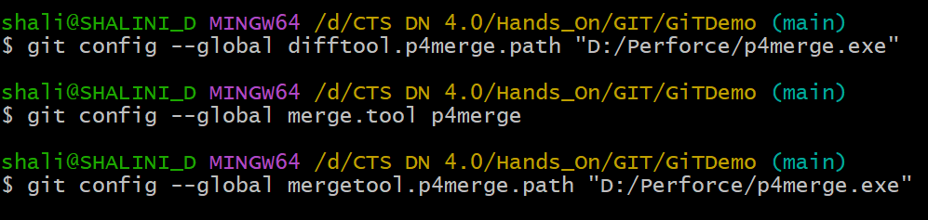

1. Create a new branch



1. List all branches

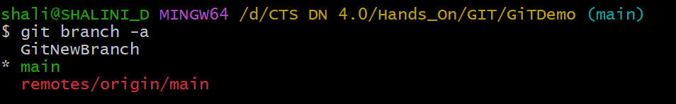

1. Switch to the new branch



1. Add new files with content

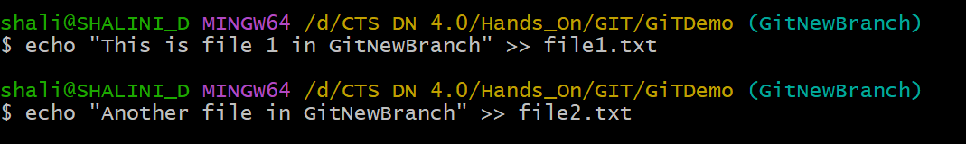

1. Stage & commit

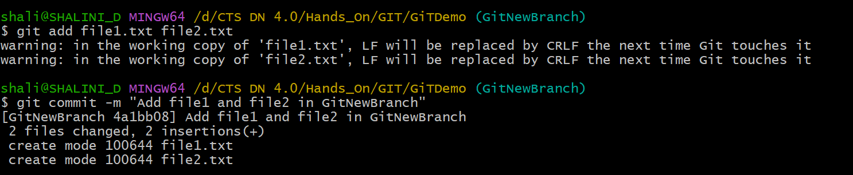

1. Check status

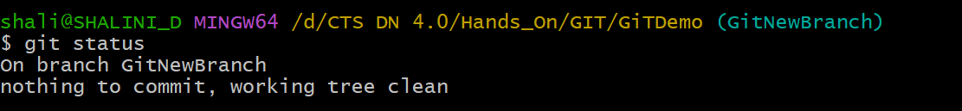

**Merging:**

1. Switch back to main

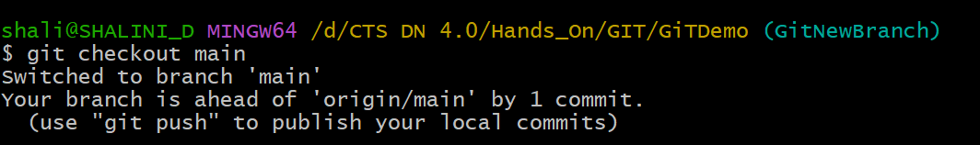

1. List differences between main and GitNewBranch (CLI view)

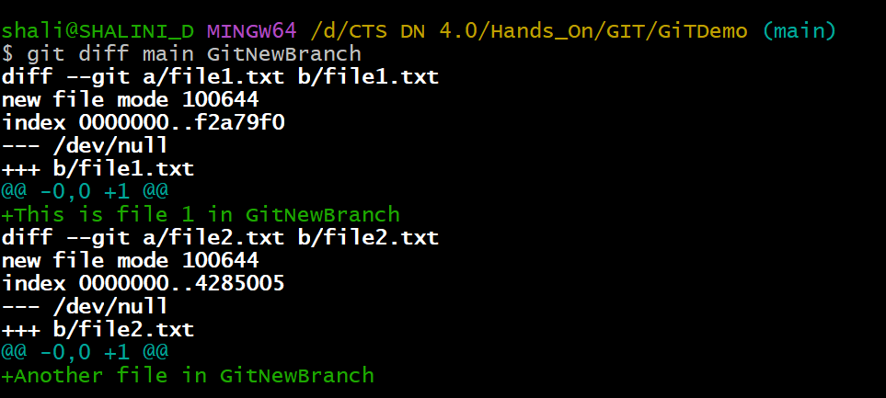

1. View visual differences using P4Merge

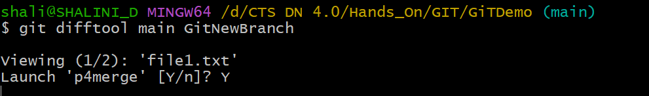

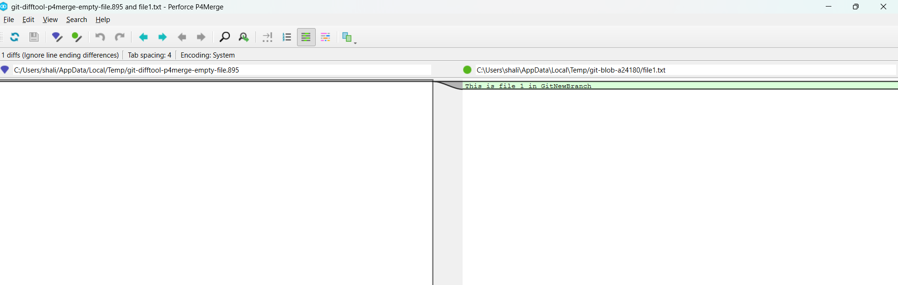

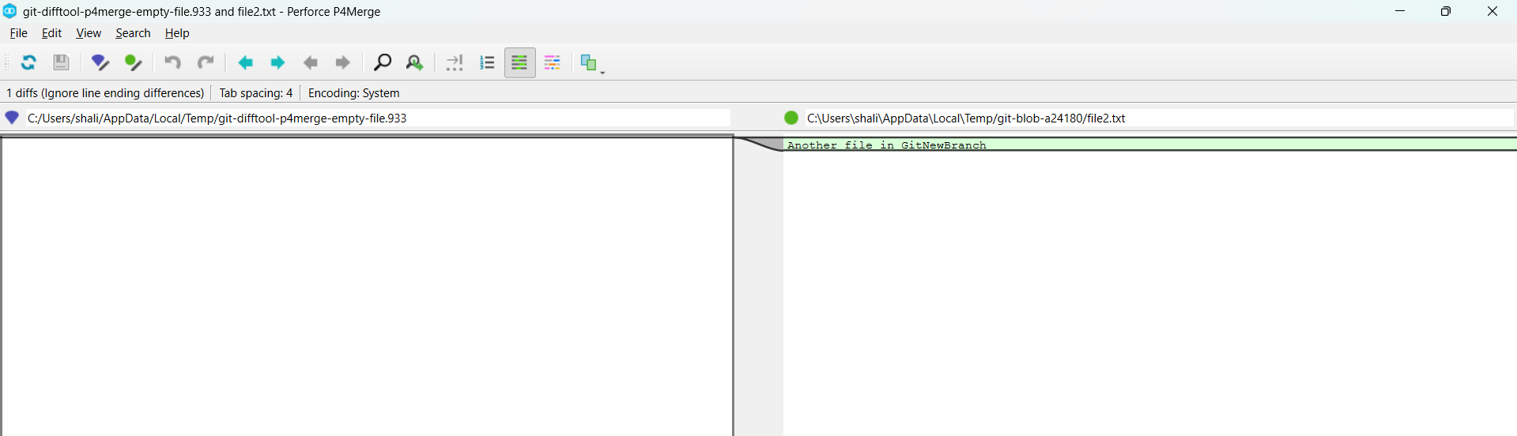

1. Merge the branch into main

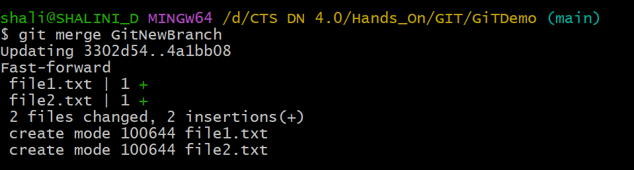

1. If there are conflicts, git will open P4Merge

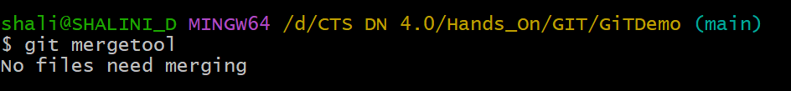

1. View merge history

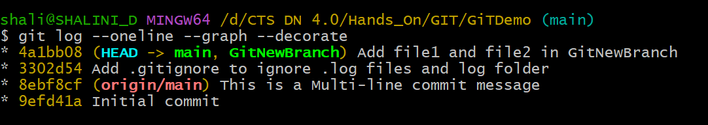

1. Delete the merged branch

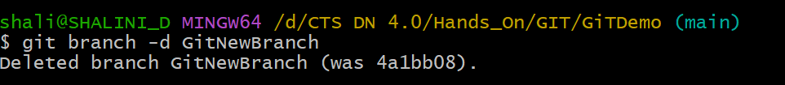

1. Check the status

